TEACHER:MWALE CHIPO

KENNETH KAUNDA SECONDARY SCHOOL DESIGN AND TECHNOLOGY DEPARTMENT
LESSON PLAN

SUBJECT: DESIGN AND TECHNOLOGY CLASS:…… … DATE:……/……./20…. DURATION:………….
BOYS:…………………… GIRLS ………………………………………. TOTAL OF PUPILS…
TOPIC: QUADRILATERALS SUBTOPIC: QUADRILATERALS
LEARNING OUTCOMES LSBAT
- Define Quadrilaterals
- Identify and describe types of Quadrilaterals
RATIONALE
Knowledge: Rectangle square, kite, rhombus, parallelogram trapezium)
Skills: Accurate construction of quadrilaterals
Values: Awareness of methods of constructing quadrilaterals
TEACHING AIDS
PART | LESSON CONTENT |  | METHOD OLOGY | LEARNER ACTIVITY
Introductio n | - Recap on the previous lesson |  | Questions and answers | Provide answers
Developme nt | QUADRILATERALS  - The quadrilateral is a plane figure bounded by four straight sides.  TYPES OF QUADRILATERALS
Developme nt | - A SQUARE  - with all four sides of equal length  - Four angles of 900 each  - Four lines of symmetry  - RECTANGLE  - Opposite sides is equal length  - All corners angles are right angles ie 900  - It has two lines of symmetry along its centre lines  - PARALLELOGRAM  - Opposite sides are parallel and equal  - Opposite pair of angles are equal.  - It has no lines of symmetry  - Opposites sides are parallel and equal  - Opposites angles are equal  - RHOMBUS  - All four sides equal.  - Opposite angles are equal but not 900  - It has two line of symmetry along its diagonals  - TRAPEZOID  - With all four sides and angles unequal  - Lines DC and AB are parallel but not equals  - It has no lime of symmetry  - TRAPEZIUM  - One pair of opposite sides parallel.  - All the angles are different  - KITE  - Adjacent Sides AD=AC, DB=BC  - One pair of opposite angles ACB and ADB are equal.  - It has line AB as its only line of symmetry | 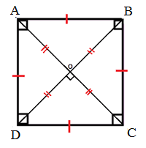  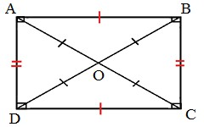  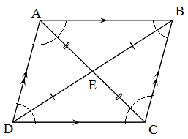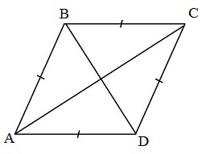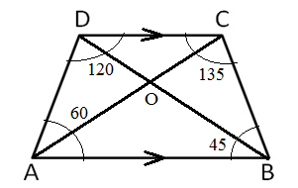
Application | CLASS EXERCISE  - Define Quadrilaterals  - Identify and describe types of Quadrilaterals |  | Questions And Answers | Provide answers
Conclusion | - Recap on the main steps and points |  | V/E
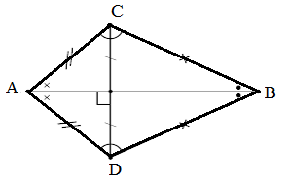
LESSON EVALUATION

TEACHER:MWALE CHIPO

KENNETH KAUNDA SECONDARY SCHOOL DESIGN AND TECHNOLOGY DEPARTMENT
LESSON PLAN

SUBJECT: DESIGN AND TECHNOLOGY CLASS:…… … DATE:……/……./20…. DURATION:………….
BOYS:…………………… GIRLS ………………………………………. TOTAL OF PUPILS… TOPIC: QUADRILATERALS SUBTOPIC: QUADRILATERALS
LEARNING OUTCOMES LSBAT
- Construction of quadrilateral from the given information
RATIONALE
Knowledge: Construction of quadrilateral from the given information
Skills: Accurate construction of quadrilaterals
Values: Awareness of methods of constructing quadrilaterals
TEACHING AIDS
……………………………………………………………………………………………………………………………………………

PART | LESSON CONTENT | METHODOLO GY | LEARNER ACTIVITY
introduction | - Recap on the previous lesson | Questions and answers | Provide answers
Developme nt | QUADRILATERALS  Construct a quadrilateral PQRS in which PR = 80, QP = 70, RS= 50, Angle P = 1200 , Angle R = 900  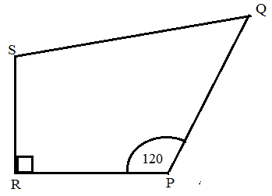  - Draw line RP= 80  - Construct angle 120 at point P and 90 at point R  - Measure RS = 50 and PQ = 70  - Draw the line from point S to point Q | Questions And Answers  Demonstration  V/E | Taking note of important points  Provide answers
Application | CLASS EXERCISE  - Construct a quadrilateral ABCD in which AB = 45 mm BC = 50 mm, CD = 40 mm, DA = 35 mm and Angle B  = 120°.  - Construct a parallelogram ABCD in which Ac = 66 mm, BD = 54 mm, and AB = 40 mm  - Construct a quadrilateral ABCD in which AB = 50 mm, BC = 30 mm, CD = 60 mm, DA = 40 mm  - and AC = 70 mm  - Construct a rhombus ABCD whose side is 5 mm and one of the angles is 75° | Questions And Answers | Provide answers
Conclusion | - Recap on the main steps and points | V/E
LESSON EVALUATION

